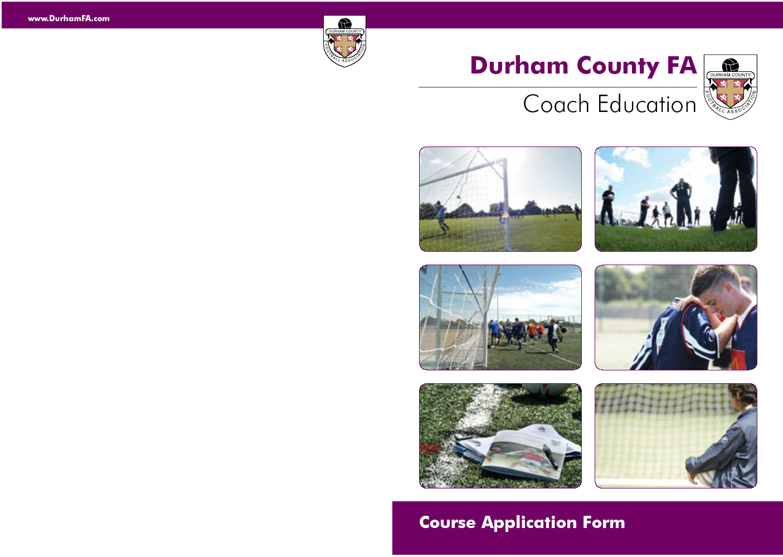
Durham County FA
Goalkeeping Coaching Award (Level 1)
___________________________________________________________
Venue:- Primrose Community Centre, Lambton Terrace, Jarrow, NE32 5QY
__________________________________________________
2010
SaturdayJuly 10th 9.00 – 5.00pm Theory / Practical
Sunday July 11 9.00 – 5.00pm Theory / Practical Assessments
SaturdayJuly 25th 9.00 – 5.00pm Practical Assessment
___________________________________________________________
Course Syllabus:-Practical Sessions &Theory Tasks
Practical Assessments

Pre requisiteLevel 1 Certificate in Coaching Football
First-Aid and Safeguarding certificate
Must bring original certificates to be accredited
_______________________________________________________________________
Cost:-£100 per Candidate
All candidates will receive FA Portfolio and FA Certification

If you are attached to a Durham County FA Charter Standard Club or a member of Durham County FA Coaches Association, the cost will be: £80 per candidate ( fee incorporates, FA portfolio and certification) .
Terms and conditions apply:
Payment must be sent with application forms and for a bursary they must be co-signed by a club secretary.
____________________________________________________________________

Tel: 0191 3872928
E-mail: development@durhamfa.com
Web: www.durhamfa.com
____________________________________________________________________
COURSE CODE :-GLKP011

Forename: ………………………………Surname: ………………………….

Address: ……………………………………………………………………………

……………………………………………………………………………………….

…………………………………………….Post Code: …………………………

Date of Birth: ……../……../……….

Tel (day): …………………………………Tel (eve): ……………………………

E-,mail: ……………………………………………………………………………..

Current Football Qualification: ………………………………………………….

Medical Conditions :………………………………………………………….

Which Club / School / Organisation do you belong to:

……………………………………………………………………………………….

Declaration: I understand that Durham County FA and its servants, agents and
employees are not under any liability whatsoever in respect of personal injury, loss or
damage however caused, while taking part in any activities of the Association.

Signed: …………………………………………….. Date: ……………………….

Charter Standard Bursary Application Only:

Name (Club Secretary/Head Teacher) …………………………………………

Signature: ………………………………………………………………………….

Completed applications should be returned to: Durham County FA,
Football Development, Riverside South, Chester-le-Street, DH3 3SJ
Course Code: GLKP011
The Football Association Goalkeeping
Coaching Award (Level 1)

For whom the course is intended
Coaches who wish to learn the basic ‘Technical’ aspects of Goalkeeping
Candidates who have obtained the minimum 1st4sport Level 1 Certificate in Coaching Football
Candidates should have a reasonable level of fitness as there is a physical content in taking part in the practical sessions.

Course Requirements
Writing materials / Notepad
Suitable playing kit, tracksuit, shorts, socks
Footwear – appropriate to the surface 3g
Water bottle
Goalkeeping Gloves
Shin pads are compulsory

Practical Work

Specific Goalkeeping warm ups and cool downs
Footwork
The ‘SET’ position
General handling techniques
Diving saves – catching / deflecting / parrying
Dealing with 1v1
Dealing with crosses
The Club Games are designed to help develop children’s ability, each game relating to a specific technique of the game.

Theory

Course Introduction
Long Term Player Development

Assessment

Candidates to deliver a 15 minute Technical Practice

